**Wireframe Document**

**Heart Disease Diagnostic Analysis**



**Revision Number - 1.2**

**Last Date of Revision - 03/07/2022**

**Swadesh Ranjan Panda and Srimanta Shekhar Mishra**

WIREFRAME DOCUMENT DESIGN

**Document Control**

|  |  |  |  |
| --- | --- | --- | --- |
| **Date** | **Version** | **Description** | **Author** |
|  |  |  |  |
| 19/06/2022 | 1.0 | Introduction, | Swadesh and Srimanta |
|  |  | Problem Statement |  |
|  |  |  |  |
| 26/06/2022 | 1.1 | Dataset Information, | Swadesh and Srimanta |
|  |  | Architecture |  |
|  |  | Description |  |
|  |  |  |  |
| 03/07/2022 | 1.2 | Final Revision | Swadesh and Srimanta |
|  |  |  |  |
|  |  |  |  |



**2 |** P a

g e H e a r t D i s e a s e D i a g n o s t i c A n a l y s i s

WIREFRAME DOCUMENT DESIGN

**We Performed Exploratory Data Analysis on Jupyter Notebook and then created a Power BI Desktop Dashboard.**

**1. What Kind of Population do we have?**

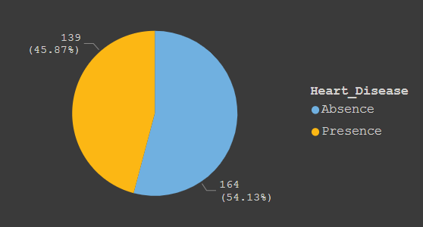

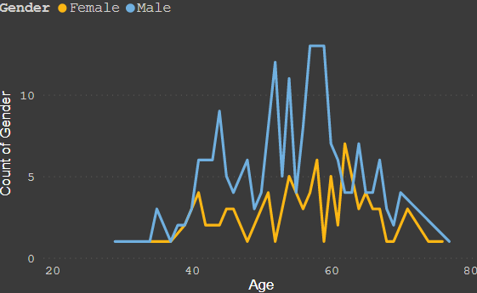

* 45.87% People suffering from heart disease.
* Elderly Aged Men are more (50 to 60 Years) and Females are more in 55 to 65 Years Category



**3 |** P a

g e H e a r t D i s e a s e D i a g n o s t i c A n a l y s i s

WIREFRAME DOCUMENT DESIGN

­­

**2. Who Suffers from Heart Disease?**

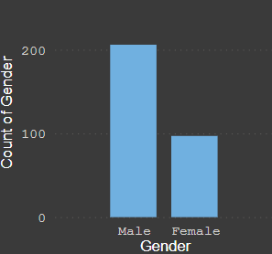

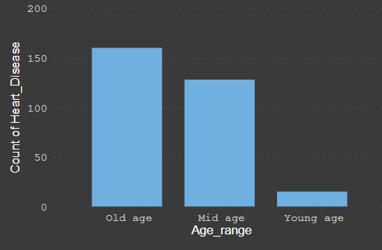

* Males are more prone to heart disease.
* Elderly Aged People are more prone to heart disease.



**4 |** P a

g e H e a r t D i s e a s e D i a g n o s t i c A n a l y s i s

WIREFRAME DOCUMENT DESIGN

**3. What symptoms people experience in heart disease**

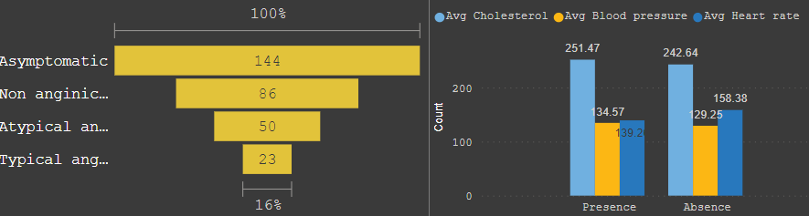

* It seems people having asymptomatic chest pain have a higher chance of heart disease.
* Asymptomatic Chest pain means neither causing nor exhibiting symptoms of heart disease.
* It seems in people high number of cholesterol level have heart disease.



**5 |** P a

g e H e a r t D i s e a s e D i a g n o s t i c A n a l y s i s

WIREFRAME DOCUMENT DESIGN

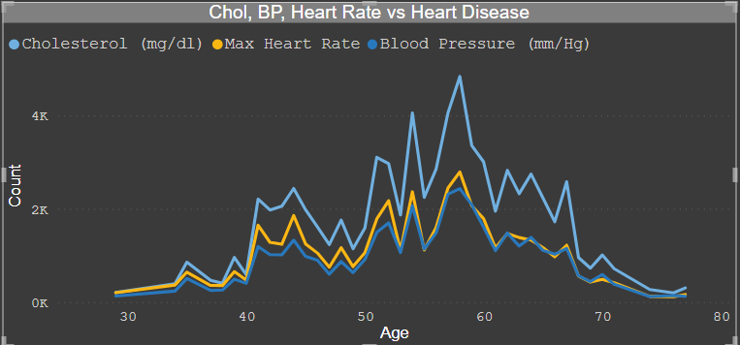

* Here we can observe that Blood Pressure increases between age of 50 to 60 and somehow continue the pattern till 70.
* Similarly, Cholesterol and maximum heart rate Increase in the age group of 50-60.

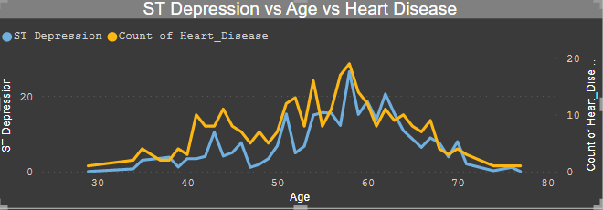

* We can observe from here that ST depression mostly increases between the age group of 30-40.
* ST depression refers to a finding on an electrocardiogram, wherein the trace in the ST segment is abnormally low below the baseline.



**6 |** P a

g e H e a r t D i s e a s e D i a g n o s t i c A n a l y s i s

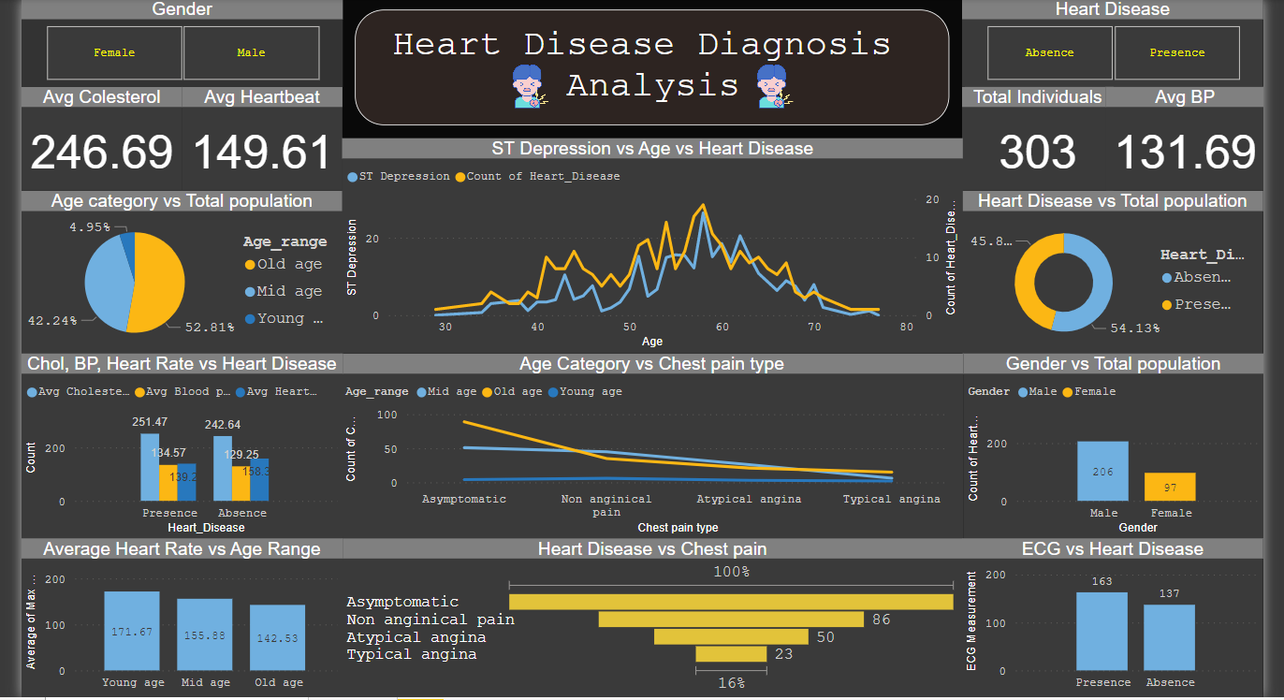WIREFRAME DOCUMENT DESIGN

The patient with the below features have all turned out to have developed heart disease:

1. age<**54**
2. Max heart rate **>152 bpm** o No. of vessels colored by flourosopy **=0** o Thalassemia is **fixed**

The patient with the below features have 88% turned out to have developed heart disease:

1. Age>**54**
   1. Peak exercise ST segment is **NOT FLAT** o No. of vessels colored byflourosopy **=0** o Thalassemia is **fixed**

* Total Patients with heart disease is 165 (54.6%) of total 303 subjects.
* Average Risk of developing heart disease is 83.39%.
* Average Resting BP for people with heart disease is 129.3 mmHg.
* Average Serum Cholesterol for people with heart disease is 242.33 mm/dl.
* Average age for people with heart disease is 52.5 years.
* Average max heart rate achieved for people with heart disease is 158.47 bpm.
* Average no. of major vessels affected for people with heart disease is 0.36.
* Average ST depression induced due to exercise for people with heart disease is 0.58.



**7 |** P a

g e H e a r t D i s e a s e D i a g n o s t i c A n a l y s i s